Assessment 1: Architecture and Space
Student Name
Institution Affiliation

Assessment 1: Architecture and Space
Introduction
Architecture can be precisely defined as any physical structure that alters with human emotions and is said to have a significant effect on history. There exists a great history of architectural design that dates back to the early Romans and Greeks. The evidence of the creativity of the architecture design that was created a long time in history is still being felt up to date. However, the spaces that we live in are affected by different factors, including culture, backgrounds, and some of our life experiences.
My Workplace
The number of hours that I spend at this structure sometimes is more than the hours that I spend at my home. I work in a healthcare facility. According to the state of my job, I typically work for eight hours every day. However, there is a pretty long break (approximately 1 hour) scheduled in between the working hours for lunch. The facility where I work occupies about 200,000 square meters. The buildings around the facility are build using modern standards. The workplace consists of several small structures with distinct rooms. Patients walk in and out of the facility all through the day and even at night seeking care for their different health complications. All the workers do not have a permanent private office since we work on a shift basis. The facility operates 24 hours; hence, we all work under a very strick shift schedule. Before entering the facility, one has to go through a security checkup. Upon completing the security scan, what one observes is the reception section, where the co-workers direct you to the respective department where care can be obtained from. With the availability of so many infectious diseases, I always remain careful not to get infected with any disease when offering care.
Additionally, this space alters my moods from high to low, an aspect that made me take long before deciding to be a permanent employee of the facility. There is a garden at one corner of the facility where the patients and the employees of the facility can always enjoy. The garden has some water features that sound awesome as the water flows over the small gray rocks. A garden is usually a perfect place for patients to get away with stress from all the forms of treatment they undergo when receiving the appointments of the doctors. Additionally, employees also visit the garden to get away the overall stress that is encountered within the facility.
Additionally, the facility has a café that serves coffee to both the employees and the patients. The café is designed within the balcony facing the garden. I love sitting at this balcony always to let warm hit my face once I am done with my shift or immediately before starting my shift. The facility building precisely appeals to all the three theoretical principles of architecture. The building was built for durability with its base made of steel beams, utility since it functions well to all those who enter the facility and a lane to all those who cannot walk without assistance or those who use wheelchairs. The last principle is the beauty, the garden and other flowers make the facility building calm and more attractive (Fiero, 2017).
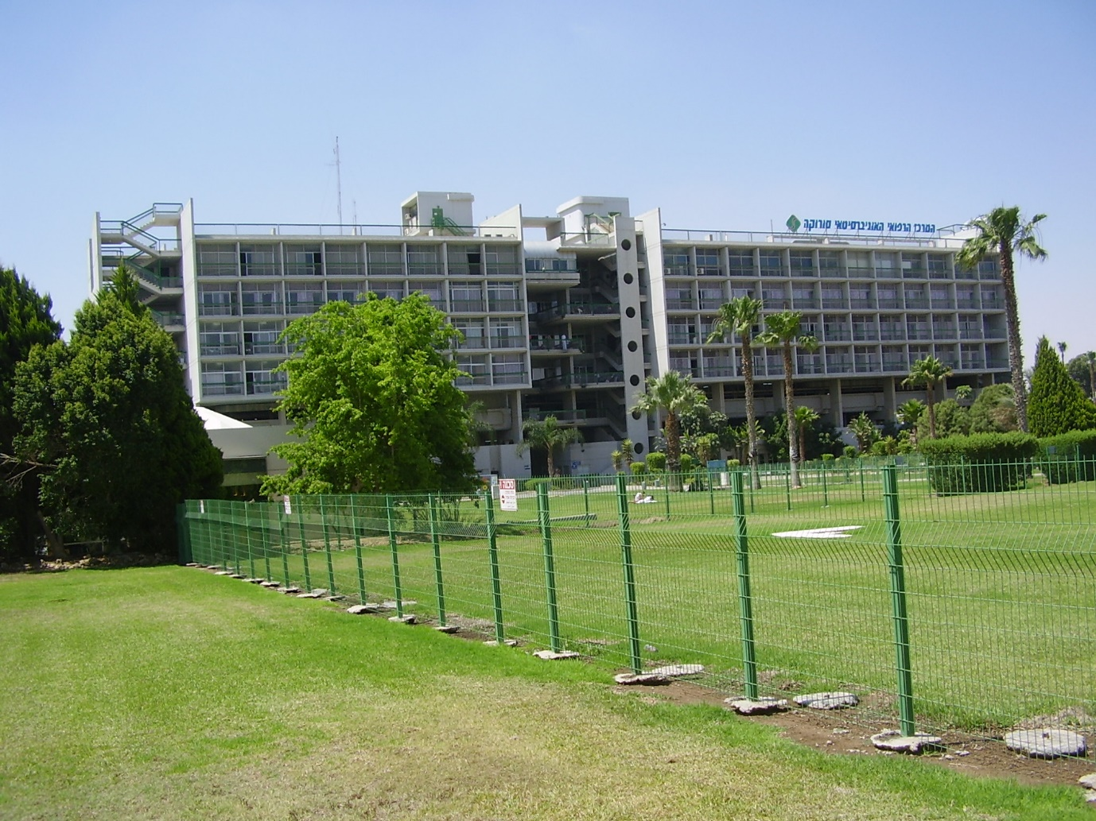
My Home
My home remains to be my favorite place for all the places that I have been to. My home is a 1,678 square foot house that was built in the early 2000s. My house has three bedrooms, a kitchen, and a washroom. The house sits on 0.17 acres of land. My house much shapes my life. We live in a compound of many families; hence, all the kinds from the houses play together in the same section. I much enjoy the feeling of community and family. I always love having different fruit tests when resting at home. From winter, summer to fall, I enjoy different scents hence making me always to feel comfortable when at home suited on the coach.
Additionally, I always love listening to music from my music system. The music makes my soul cool, especially when I come from work, much exhausted. I enjoy listening to the sounds of children playing adjacent to my house. Some of the children are too young and laugh very loudly while playing hence reminding me of how childhood life was so simple. I love the moments when we gather together at the table as a family and play board games or even cards. The most enjoyable and memorable moments are the laughter that fills the house as we proceed to play the games and cards. We spend most of the family nights cooking dinner together. The most popular meal that we enjoy making as a family is homemade pizzas. Additionally, I am always pleased by the security around the place we live in.
My house has only two of the three theoretical principles of architecture. The first principle is beauty, as we have worked to make the house modern with different scents. The second principle is a utility, which is functional due to the precise planning of the floor. However, I am not particular about the durability of the house. I am not sure that the house can withstand several storms that happen in different parts of this country (Fiero, 2017). However, the home remains to be my favorite place since I always feel better being where my family is. I can make all possible adjustments at home. For instance, I can control the music that is either make music lenders in the house or quiet with no sounds at all.

My Church
The third-place that I enjoy spending some time in is the church. The architectural structure of the church takes the form of a cathedral. The design of the church does not matter in modern society, so long as those worship can gather there to worship and pray. However, space was built to accommodate more parishioners in the state and was built as a modernist building. There are various structures around the church, including a school, home for priests and nuns, a pond, and a cemetery. The design of the church is spatial and open as one has to walk in the massive form of a garden are to the sanctuary officer where staff and priests are located. There are various statutes around the church. I love to go and conduct personal prayers at the statutes whenever I visit the church. A good atmosphere with minimal sounds (sounds come from birds only) makes the church a better place to spend some time. The architecture of the church gives me two close mixed feelings that are spiritual closeness feeling and community identity feeling.
The church comprises of the three architectural principles that are durability, utility, and beauty. The pond makes the church attractive to worshipers. On the other hand, the church buildings are constructed using concrete beams with a strong base. Additionally, the walking paths are well labeled and have few contains allowing all people to move around the church compound (Fiero, 2017).
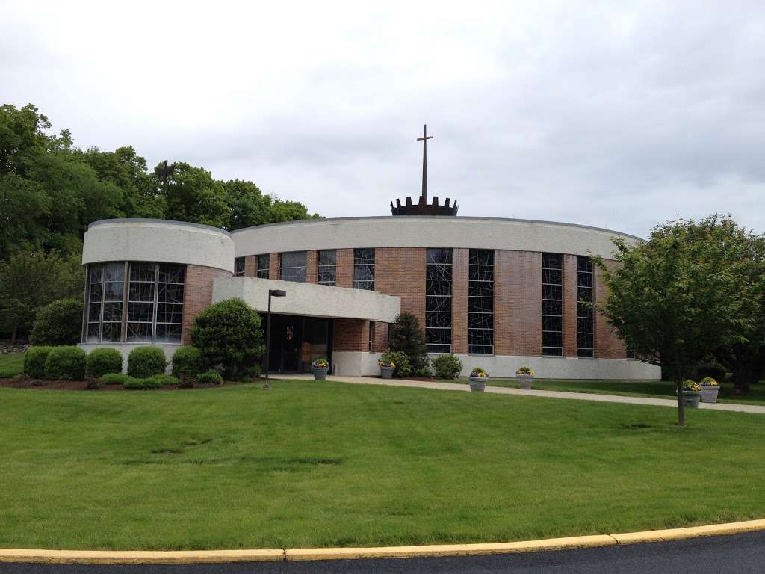
Conclusion
While studying the three types of architecture that much impact my life, one thing that they all have in common is the sense of experiences while observing. One of common sense that I noticed is sound vibrations traveling in the ears then being converted to an awesome feeling that makes the brain to relax (Unsworth & Robison, 2018). The brain always tells us what we are hearing and what sound it is. Research depicts that the state of mind is affected by sounds hence making sound one of the most critical drivers to emotions. Some sounds make me unsettled and frightened, especially the sound that I hear while asleep. However, immediately after hearing such sounds, other soothing sounds run across my mind making me relaxed. With many kinds of research having being made on the effects of sounds on the individual state of mind, it also relates to how one sees and interpreters architecture. The building is built in different ways, depending on the functions they are built for. It is essential wee use all the senses to ensure that we capture all the architecture principles. The architecture will always give different impressions. Lastly, we will always get different feelings according to our interpretations of the architectures.

References
Fiero, G. (2017). Landmarks in Humanities, 4th Edition. [Bookshelf Online]. Retrieved from https://online.vitalsource.com/#/books/126025349X/
Unsworth, N., & Robison, M. K. (2018). Tracking arousal state and mind wandering with pupillometry. Cognitive, Affective, & Behavioral Neuroscience, 18(4), 638-664.

